Course: CEN 4010 (Principles of Software Engineering)

Semester: Spring 2018

Milestone 5: Final Project Portfolio

Team name: Five Bros Chilling in a Hot Tub (Group 3)

Project name: Florida Atlantic University Original Web eLectronics Store (FAUOWLS)

Project site: <http://lamp.cse.fau.edu/~CEN4010_S2018g03/FAUOWLS>

Youtube Video Demonstration: <https://www.youtube.com/watch?v=of9FsvFjclg>

Team:

* Joshua Cordes, Product Owner, Developer, jcordes@fau.edu
* Martin Daniel Sanchez, Scrum Master, Developer, martinsanche2016@fau.edu
* Brett Marks, Front-end Team Lead, Developer, marksb2016@fau.edu
* Alvaro Feola, GitHub Master, Developer, afeola2013@fau.edu
* William Young, Backend Team Lead, Developer, wyoung2012@fau.edu

Date: 2 May 2018

|  |  |
| --- | --- |
| History Table | |
| 19 Feb 2018 | Initial submission of Milestone 1 |
| 22 Mar 2018 | Revisions of Milestone 1 added to Milestone 3 |
| 26 Mar 2018 | Initial submission of Milestone 3 |
| 16 Apr 2018 | Initial submission of Milestone 4 |
| 2 May 2018 | Initial submission of Milestone 5; revisions of Milestone 3 noted in Milestone 5 |

3.2 Product Summary

To facilitate inventory-tracking, we are producing for FAU’s Perry Weinthal the Florida Atlantic University Original Web eLectronics Store (FAUOWLS), where students and university employees will be able to search for and purchase electronics items they seek, and Perry and his team will be able to keep track of all equipment and service requests as they come in and go out. FAUOWLS will allow students and faculty at FAU can purchase or rent, at little to no cost, many electronic parts that might otherwise be pricey for those on a budget.

Major committed functions:

* Prospective users create an account using their FAU Z-number as a primary key and standard FAU username as their FAUOWLS username.
* Items are separated into product Categories, navigable from the home page.
* Admin imports to Inventory a spreadsheet file with info on Items to update or add.
* Admin exports from Inventory a spreadsheet file with info on Items currently in Inventory.
* Admin creates Kits containing multiple existing Items in Inventory, with the correct Quantity of each Item subtracted from Inventory when each quantity of the Kit is added.
* Admin sees in-browser table of current Inventory, where he or she can update or add items as desired.
* Admin can mark rented items as returned, updating the inventory.

Unique features:

* Site includes items separated by Categories, avoiding potentially inefficient searches.
* When uploading a spreadsheet to Inventory, if an Item’s Category is not yet in the database, a new one is added to which other Items can then be added in the future.
* When Admin/Staff cancels an order, Inventory Quantities are updated automatically.

Product links:

* Home page, geared toward Clients: <http://lamp.cse.fau.edu/~CEN4010_S2018g03/FAUOWLS/>
  + Home page is publicly available, but functionality contained within is restricted to logged-in users.
  + Account jcordes (password: admin) available to use if desired. Note: Admin privileges.
  + After registering at <http://lamp.cse.fau.edu/~CEN4010_S2018g03/FAUOWLS/security/register.php> and clicking the link in your confirmation email, log in at <http://lamp.cse.fau.edu/~CEN4010_S2018g03/FAUOWLS/security/login.php>
    - Note: New accounts only receive Client privileges until an Admin grants them higher ones.
* Inventory page for Admin and Engineering Lab Staff: <http://lamp.cse.fau.edu/~CEN4010_S2018g03/FAUOWLS/inventory/>
  + Restricted to logged-in users with appropriate privileges.

3.3 Milestone documents

1. Modified Milestone 3 document:

2

From Room 205 of Florida Atlantic University’s (FAU) Engineering East building, Perry Weinthal sells or leases various electronic parts and equipment, as well as manufactured pieces (such as those from a 3D printer) by request. To facilitate inventory-tracking, we are producing the Florida Atlantic University Original Web eLectronics Store (FAUOWLS), where students will be able to search for and purchase items they seek, and Perry and his team will be able to keep track of all equipment and parts as they come in and go out. Many web stores, such as Newark element14 (<http://www.newark.com>) already exist that sell electronic equipment, and Perry often purchases equipment and parts from such sites, in addition to purchasing from more general-purpose web stores like eBay (<https://www.ebay.com>).

The uniqueness of the FAUOWLS is that it would primarily target students at FAU either currently taking or who have taken courses in computer science, computer engineering, or electrical engineering, who would be able to purchase at no cost many electronic parts that would otherwise cost some non-zero amount, as well as lease or rent more complex equipment for free - equipment that would otherwise be prohibitively expensive for the average university student. FAUOWLS will also allow those on Perry’s team to locate equipment in various laboratories upon request, saving them the trouble of either having to memorize the location of every part or spend excessive time rummaging through drawers to find what a student seeks. Faculty, additionally, will be able to purchase, rent, or lease equipment or parts, at little to no cost, while FAUOWLS will allow Perry’s team to track all such prices in one central database.

Ultimately, FAUOWLS would allow Perry and his team to be more productive, and allow students and faculty needing parts and equipment to have a clear, easily accessible system for finding and obtaining what they’re looking for to excel in their courses - or even engineer their own experiments.

3. Competitive Analysis

|  |  |
| --- | --- |
| **Competitors** | **FAUOWLS** |
| Multiple Ways to Pay | No Money Exchange Needed |
| Algorithms for Personal Recommendations | Focus on Optimizing Search/Sort Algorithms |
| Focus on Advertising | Clean Presentation Focusing on Functionality |

Our focus for FAUOWLS with respect to our competitors has not changed since the previous submission. We still believe our goal should be quick functionality and clean presentation over advertisement-filled pages and personal recommendations based on user profiles. If recommendations are added later, they will be focused around courses that the user is taking. Since we are not charging users any sort of currency, there is no need for advertisements within the site, unless it is a kit or service that is ordered frequently, in which we could add a quick link on the front page. In regards to the former point, our focus being elsewhere other than advertising allows us freedom from falling in line with our competitor sites. However, we still plan to utilize the organizational conventions that other web stores use, such as categorized inventory and navigational menus. This will allow users to find what they need swiftly, along with keeping different pages of the store clutter-free. Ultimately, the store will compete with search and load times of bigger competitors, along with the ease of utility that is found among the best sites.

4

Data definition:

**Admin** – Administrator’s account. Will be able to create/edit Staff and Client accounts, approve item requests from Clients and order items from Vendors to send to Inventory.

Admin attributes:

* Username - Username with which Admin logs in.
* Password - A single password/key used by the Admin to log in to his/her account.

**Client** – Person (FAU student, faculty et al.) ordering or renting item(s) from Inventory. May also request items from Admin.

Client attributes:

* Znumber - Primary key. Client’s FAU-assigned Z-number.
* Password – Password/key for client to log in to his/her account. Created by user.
* Major - Client’s major at FAU. User-selected.
* Courses – Client’s current courses at FAU.
* Graduation date – Client’s expected graduation date.
* Cart – Stores part number for each item added for prospective purchase/rental by Client. Where final purchase or rent function can be applied.
* Purchase and Rent History – A list of all previous purchases and rentals. Includes Part Number, Order or Rent Date, Pick-up Date, and Return Date if part was or is being rented.
* Client’s Orders – Current client pending orders.

**Engineering Lab Staff** – Account that shall be able to view Client orders, view Client account history, create Kits, add items to Inventory, and add new Vendors.

Engineering Lab Staff attributes:

* Username - Each engineering staff member will use a unique log-in created by the Admin.
* Password - A single password/key for Engineering Lab Staff to log in to his/her account.

**Inventory** – Stores product inventory available for clients to purchase/rent.

Inventory attributes:

* Part number - Primary key for Inventory item.
* Short Description – A short text description of the product in minimal detail.
* Long Description – A detailed text description of the product.
* Image – Capable of storing multiple images in specified format.
* Data Sheet - Data in an Excel spreadsheet or PDF that can be uploaded.
* Location in Lab – Specifies where Inventory item located in lab.
* Quantity – Quantity of Inventory item available in lab for purchase/rent.
* Purchase or Rent – Indicates whether Inventory item available for purchase, rent, or both.
* Barcode - Bar code associated with product.
* Purchase Price – Original price per item paid to Vendor for purchase by lab.
* Retail Price - Price per item when sold to Client.
* Bulk Selling Price – Price per Bulk Quantity at which item is sold to Client.
* Bulk Quantity - Quantity of Inventory item for which Bulk Selling Price applies.
* Jobber Selling Price - Price per item when sold to a middle man.
* Vendor part number – The vendor’s part number.
* Part availability per client – A limit set on each part that a client can order depending on the group certification.

**Vendor** – Company from which some item in Inventory is ordered or can be ordered.

Vendor attributes:

* Name – Name of vendor company.
* Address - Physical address of the vendor.
* Account number - Each vendor will have a unique account number used as a primary key.
* Order History – List of all items with Quantity and Purchase Date ordered by Admin.

5

Overview:

The FAUOWLS will be used by both Engineering Lab Staff and FAU students and faculty as a way to distribute goods for engineering projects, as well as services, generating a record of transactions. Students will be able to identify through their FAU ID, log into their account and "purchase"/"rent" any needed parts or "hire" troubleshooting and printing services. For these services, students will need to upload different types of files. Staff will be able to keep track of real-time inventory and their location; when orders are generated, these should indicate the physical location of the products. Products and suppliers can be created and modified by the Staff. Products will have an image associated to it, as well as data sheets, which can be uploaded by clients with a pending approval from the Staff, and different prices depending on the customer classification. There will be assembled products, which will be conformed of other products, affecting the inventory. They system will offer an option to add the assembled kits to stock, where it will calculate if the necessary amount of input products is in stock, if there is no sufficient stock the system will inform what is missing.

Scenario:

Jack is a Computer Engineering student taking Logic Design, therefore skilled on computer tasks. At the beginning of the semester Jack is given a kit including two breadboards, LEDs, resistors and various other parts. Unfortunately, Jack makes a mistake and causes some LEDs to stop working. On the next class, he talks to his classmates about this problem, since he needs a white LED to finish his Lab project; they suggest that he uses FAUOWLS to order the part he needs. Jack signs in to FAUOWLS using his FAU ID and Z-number, browses for the white LED he needs and orders it at no cost. Later, he goes to room 205 on Engineering East building, where Perry or another member of Perry’s team scans Client’s OWL Card, pulls up his order, which indicates where in the Engineering Lab the white LED is located, and delivers it to Jack.

Initial Assumption: The user has successfully signed up to the FAUOWLS and the item needed is in stock.

Normal: When signing up, the user must enter his personal information and Z number. When browsing for the desired item there is a search function to find the item, which has a description, photo and data sheet to avoid confusion.

What can go wrong: User may order the wrong item since parts often look alike and user may not pay attention to data sheets.

System state on completion: After ordering, the stock of the item is reduced by the amount ordered. There is a record of the transaction on the system.

Scenario:

John is a FAU engineering student who works at the Engineering Lab on Engineering East building. As part of his routine, he logs into FAUOWLS system and checks the pending orders. He finds that a student Jack made an order for a custom-built circuit board with the necessary files attached and specific comments, which John uses to build it. Upon its completion, John sends an email to the student saying the order is ready and leaves the package ready for its collection. Jack arrives to the Engineering Lab, where his OWL card is scanned by John to pull up his order and confirm his identity. Then John gets the prepared order, hands it to Jack and marks the order as completed.

Initial Assumption: The circuit board materials and machine are in stock and available.

Normal: When making the order, user must include files and comments regarding the desired circuit board.

What can go wrong: User may include wrong files, wrong file type, comments or file with errors resulting in a delayed, not accepted order or a circuit board that is not desired.

System state on completion: After ordering, there is a record of the transaction on the system.

Use Cases:

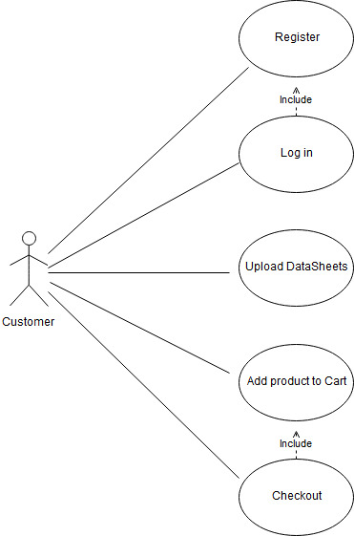

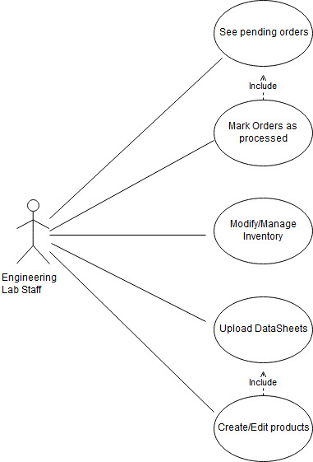

6 High-level Functional Requirements

1. Account system shall allow for students or staff to make purchases using Z-number. (no real money exchanged). **1 - must have**

a. Rental/leases shall have a strict time limit.

b. Admin shall be able to track what is taken and how much to keep track and order when supplies are low.

2. Admin shall be able to apply separate price for Jobbers, those purchasing as a middle man, such as another FAU department. **2 - desired**

3. Admin shall be able to apply separate Bulk price for when client requests a large amount of an item. **2 - desired**

4. Store shall produce a live-updating spreadsheet on the website which shows past rental/lease dates, inventory etc. **1 - must have**

5. Item page shall tell Admin and Engineering Lab Staff where to find an item in EE205. **2 - desired.**

6. Client shall be able to upload a file for 3d Printing, circuit board milling or laser cutting. (.jpg, .tiff, etc.) **2 - desired**

7. There shall be a list of vendors and their websites for easy access. **2 - desired**

8. Pictures for each specific item will be able to be uploaded to the webstore. **3 - opportunistic**

9. Any special orders will send an email notification to those who ordered the item that it is ready. **2 - desired**

10. There shall be a standard module implementation for barcodes. **3 - opportunistic**

11. Students should be able to upload data sheets that can be used at the staff’s discretion. **3 - opportunistic**

12. Account should keep track of client’s purchase/rental history. **1 - must have**

13. Staff and Admin shall have privileges that Client won’t. **1 - must have**

14. Admin shall manage accounts with permissions unavailable to Lab Staff or Client. **1 - must have**

15. System shall subtract item quantity from Inventory after purchase or rental, and shall add to Inventory when rented item is returned. **1 - must have**

16. Any item request shall be submitted to FAUOWLS as a ticket. Engineering Lab Staff shall see the request immediately upon submission for order to be fulfilled. **2 - desired**

7. Non Functional Requirements:

1. To access FAUOWLS functionality, user shall log into a dedicated FAUOWLS account.
2. If a student orders an item for a specific course, the system shall not need to check if student is currently registered for the course.
3. Expected load is no more than 300 simultaneous users.

8. High-level system architecture and database organization

Database Organization:

|  |  |  |  |
| --- | --- | --- | --- |
| **Table name** | **Fields** | **Primary/**  **composite key** | **Foreign keys** |
| Barcodes | perry_part_num  barcode | {perry_part_num, barcode} | `Barcodes`.`perry_part_num` -> `Inventory`.`perry_part_num` |
| Categories | category_code  category_name | {category_code} | NONE |
| Comments | perry_part_num  z_num  comment  rating  upvotes  downvotes | {perry_part_num, z_num} | `Comments`.`perry_part_num` -> `Inventory`.`perry_part_num`  `Comments`.`z_num` -> `Store_users`.`z_num` |
| Course_info_by_user | z_num  CRN | {z_num, CRN} | `Course_info_by_user`.`CRN` -> `Course_sections`.`CRN`  `Course_info_by_user`.`z_num` -> `Store_users`.`z_num` |
| Course_sections | CRN  code_letters  code_num  title  college  department  semester  year | {CRN} | NONE |
| Data_sheets | perry_part_num  file_name  data_sheet | {perry_part_num, file_name} | `Data_sheets`.`perry_part_num` -> `Inventory`.`perry_part_num` |
| Images | image  image_name  perry_part_num | {image_name, perry_part_num} | `Images`.`perry_part_num` -> `Inventory`.`perry_part_num` |
| Import_Inventory | perry_part_num  short_description  long_description  location_in_lab  quantity  purchase_or_rent  retail_price  retail_price_promo  retail_markup  jobber_price  jobber_markup  bulk_price  bulk_markup  cost_to_replace  cost_avg  category_code  category_name  barcode1  barcode2  barcode3  barcode4  barcode5 | {perry_part_num} | NONE |
| Inventory | perry_part_num  short_description  long_description  location_in_lab  quantity  purchase_or_rent  retail_price  retail_price_promo  retail_markup  jobber_price  jobber_markup  bulk_price  bulk_markup  cost_to_replace  cost_avg  category_code | {perry_part_num} | NONE |
| Inventory_transaction | id  transaction_type  transaction_num  transaction_date  operation  perry_part_num  quantity | {id} | NONE |
| Keywords | perry_part_num  keyword | {perry_part_num,  keyword} | `Keywords`.’perry_part_num` -> `Inventory`.`perry_part_num` |
| Kits | item  input  line  quantity | {item, input} |  |
| Perry_orders | order_num  vendor_name  date  total_price | {vendor_name, order_num} | `Perry_orders`.`vendor_name` -> `Vendors`.`vendor_name` |
| Perry_order_items | order_num  vendor_name  vendor_part_num  quantity  price_per  total_price | {vendor_name, vendor_part_num, order_num} | `Perry_order_items`.`vendor_part_num` -> `Vendor_items`.`vendor_part_num`  `Perry_order_items`.`order_num` -> `Perry_orders`.`order_num` |
| Store_users | user_type  client_retail  client_jobber  client_bulk  first_name  last_name  username  address  city  state  zip_code  z_num  major_1  major_2  minor_1  minor_2  phone  FAU_email  password  grad_semester  grad_year  confirm_code | {z_num} | NONE |
| tbl_product | id  name  image  price | {id} |  |
| User_orders | order_num  z_num  order_date  order_status | {order_num} | `User_orders`.`z_num` -> `Store_users`.`z_num` |
| User_order_items | order_num  z_num  perry_part_num  quantity  price_charged_per  net_profit  student_bool  faculty_bool  for_personal_bool  rented_bool  return_by  returned_bool  delivered_bool | {order_num, perry_part_num} | `User_order_items`.`z_num` -> `Store_users`.`z_num`  `User_order_items`.`order_num` -> `User_orders` -> `order_num` |
| Vendors | vendor_name  website  acct_num  address  city  state_province  country  phone  email  contact_name_last  contact_name_first | {vendor_name} | NONE |
| Vendor_items | vendor_name  perry_part_num  vendor_part_num  price_per | {perry_part_num, vendor_name, vendor_part_num} | `Vendor_items`.`vendor_name` -> `Vendors`.`vendor_name`  `Vendor_items`.`perry_part_num` -> `Inventory`.`perry_part_num` |

Media storage:

* Images and other attachments (e.g., data sheets) shall be stored in the database.
* File types
  + Images for Inventory, service requests, data sheets: JPG, TIFF, PNG, SVG
  + 3D printing requests: STL
  + Circuit board milling service request: GBR
  + Data sheets: PDF, DOC, DOCX, JPG, TIFF, PNG, SVG

Search/filter architecture and implementation:

* All users shall query all records based on associated Categories in the database.

Major API’s: no major original API’s shall be produced for this project.

Describe any significant non-trivial algorithm or process:

* Staff and Admin shall see list of unfulfilled orders, ordered by requesters’ Z-numbers, and click to confirm when an order has been delivered.
* Staff and Admin shall see list of rented items and click to mark an item as Returned.

9. High-level UML diagrams

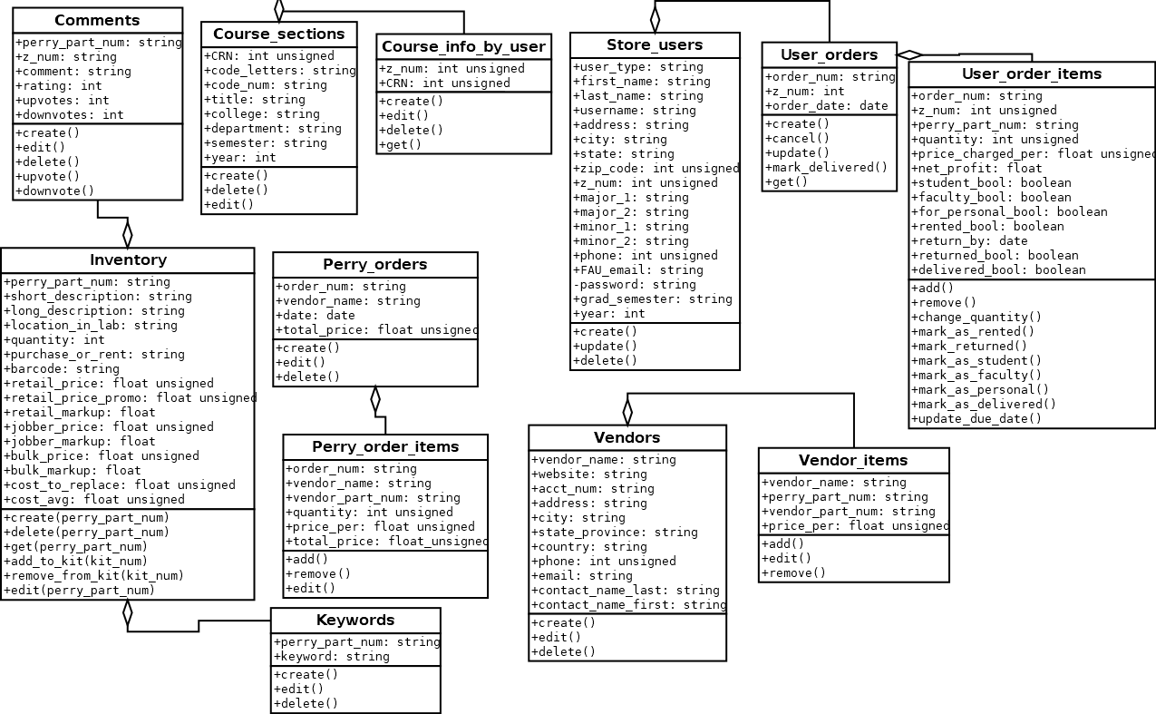

10. Key Risks

As it stands currently, the most relevant risks our team faces revolve around skill and schedule. While most of us have some experience in front end web development, few have experience, if any, with databases and back end development. This makes it difficult to evaluate exactly how much time we need to set up inventory and inventory management tools, and also a framework for searching the database and retrieving accurate results. The plan, at this time, is to utilize what we know collectively, in SQL and PHP, and do rapid research to find functionalities that we need and implementing them within our code as necessary.

In regards to schedule risks, there isn’t much to be done about conflicting schedules and availability. Most of our team has responsibilities outside of this project that cannot be rescheduled or avoided. We will continue as we have been with meetings and rely on each other to do their part on time and ask for help as needed. As it stands, the team has handled conflicting schedules exceptionally and will continue that trend through the duration of the project.

Another key risk is that whereas the original plan, by request of Mr. Weinthal, was to connect our application to FAU Single Sign-On for log-in. However, when this was broached with the university’s Office of Information Technology, it was deemed infeasible, as it would require too complex a process for those in charge to deem it worth it, unless and until our project is chosen by Mr. Weinthal to be his official web store. We were provided some instructions for connecting to LDAP, but it was far easier to make our own accounts system and leave that be for now.

2) Instructor’s feedback for Milestones 3 and 4:

1. Milestone 3:
   1. Grader was frustrated at our lack of guidance on what keys were available to search in our vertical prototype, which was a simple search bar for pulling info on an item with a given Part Number. We clarified with the grader over email that the keys available at the time were all those in the spreadsheet Mr. Weinthal had provided the class on Canvas of test data.
   2. Grader lamented our lack of a copy of our M3 document in our team GitHub. This has since been remedied.
2. Milestone 4:
   1. Grader expressed concern about spreadsheet importation for inventory additions, specifically regarding how they’re stored in the database. Uploaded CSV files are stored in a designated directory and info is pulled from them to be uploaded to a table in the database. From there, a stored procedure moves the new information to their dedicated tables (e.g., barcodes to the `Barcodes` table). If an imported file has the same name as another file already in the relevant sub-directory, the server automatically appends an integer value; e.g., if there’s a file `test.csv` and a user uploads another file `test.csv`, the new file will become `test(1).csv`. Additionally, if an item with a given Part Number is already in the database, the record is updated with any new info from the file.
   2. Grader also expressed concern about various functions on the homepage that were non-functioning at the time. These have since been completed.

3.4 Product screenshots

Import/export (admin view):

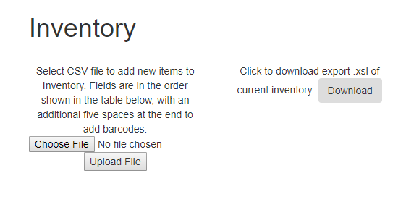

Inventory listing and create, edit, delete, and read a single item (admin view):

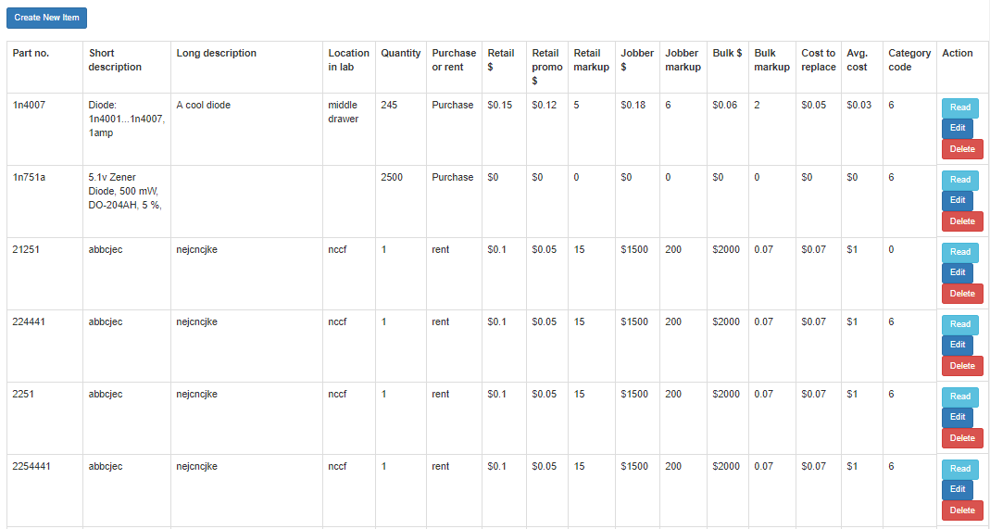

Adding quantity to existing item (admin view):

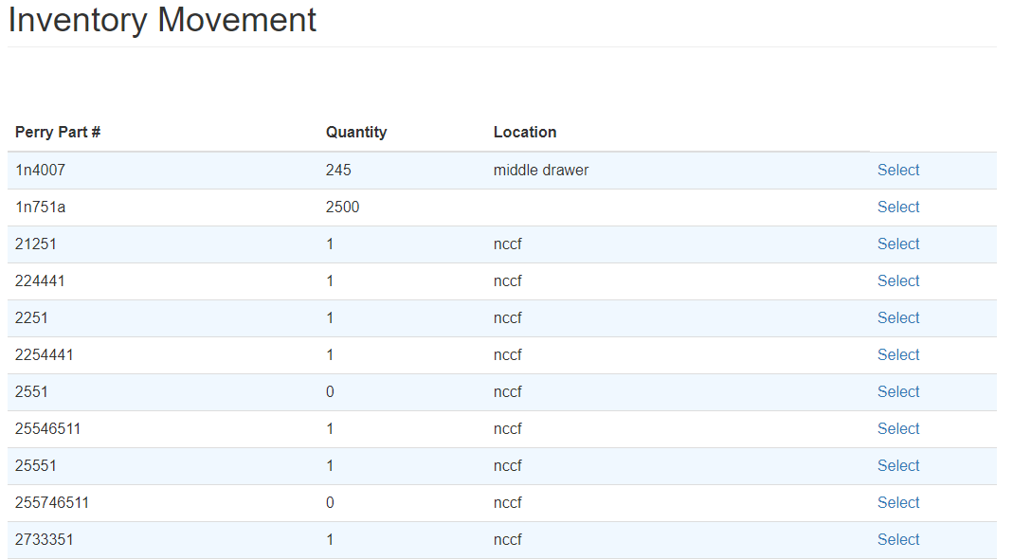

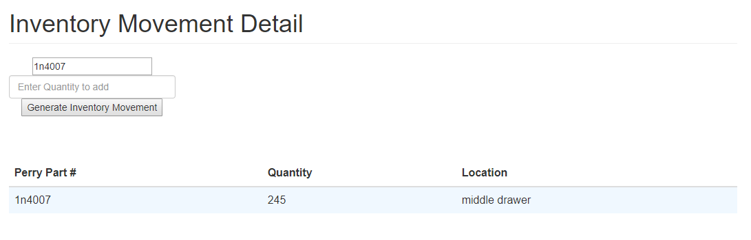

Image upload (admin view):

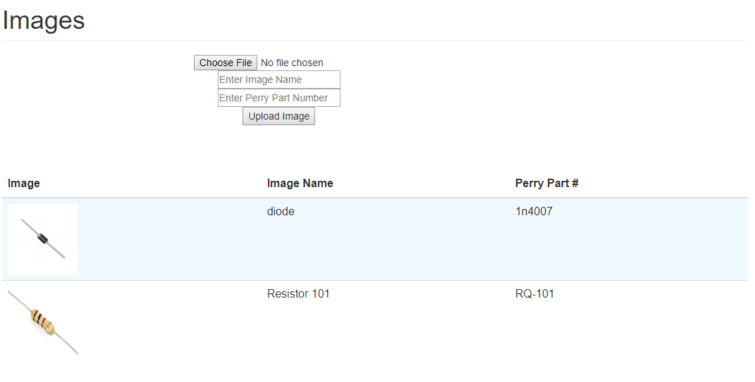

Pending orders (admin view):

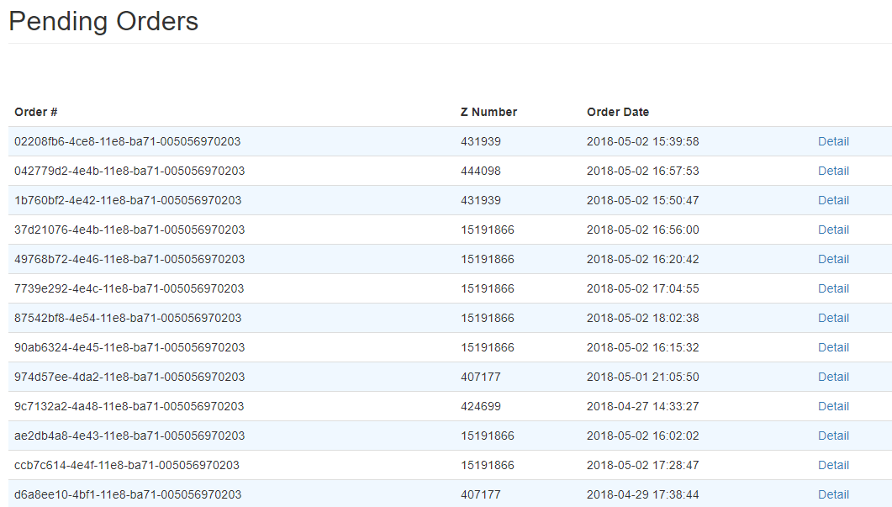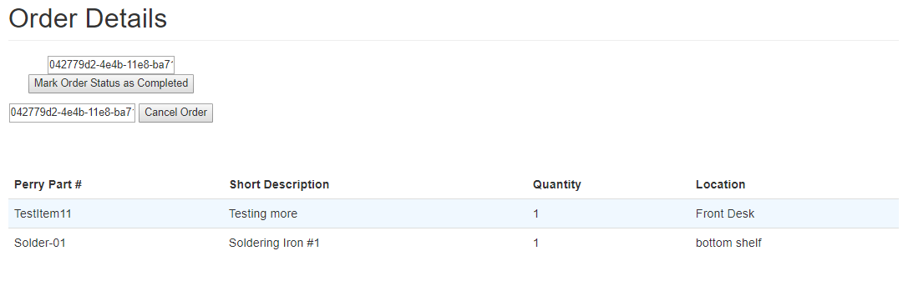

Previous orders (admin view):

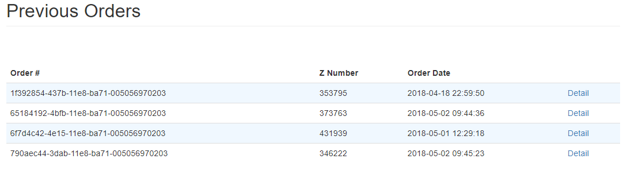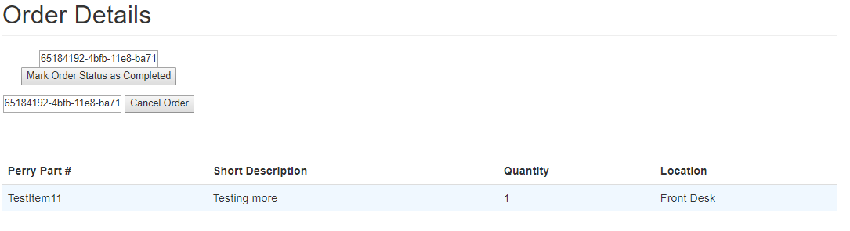

Cancelled orders (admin view):

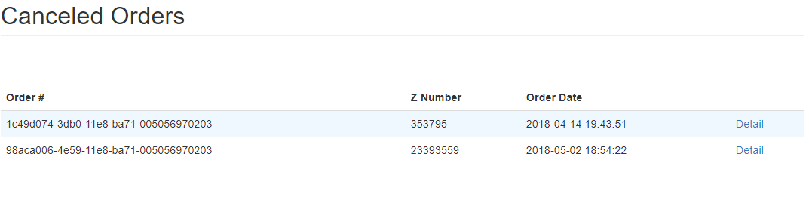

Rentals (admin view):

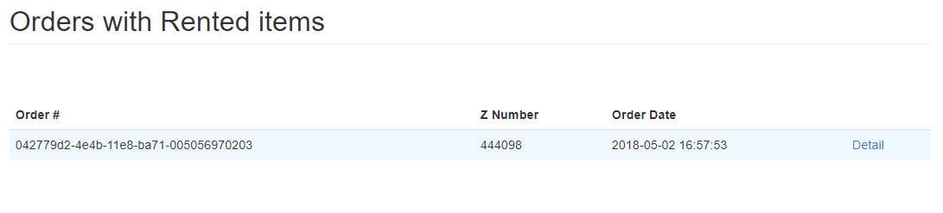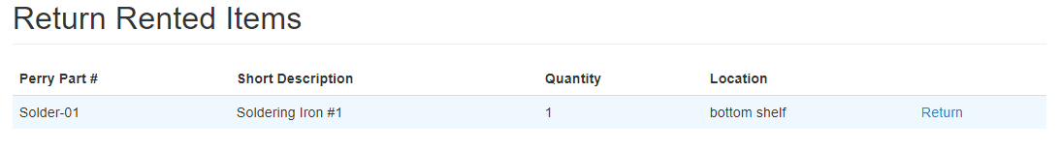

Kits - initial creation, existing stock, quantity addition (admin view):

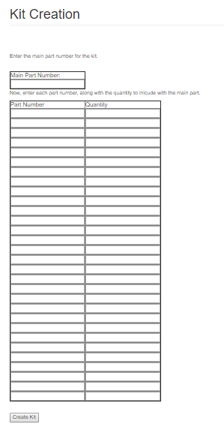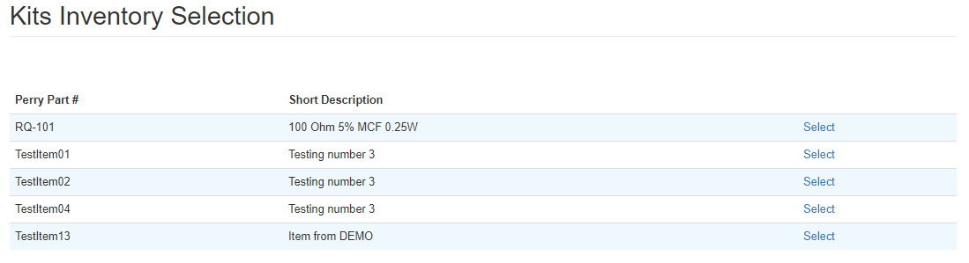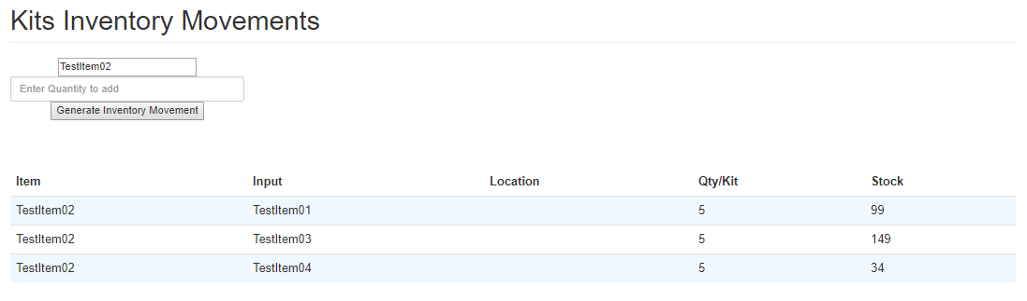

Homepage: categories, search, view cart, access product listing and find kits:

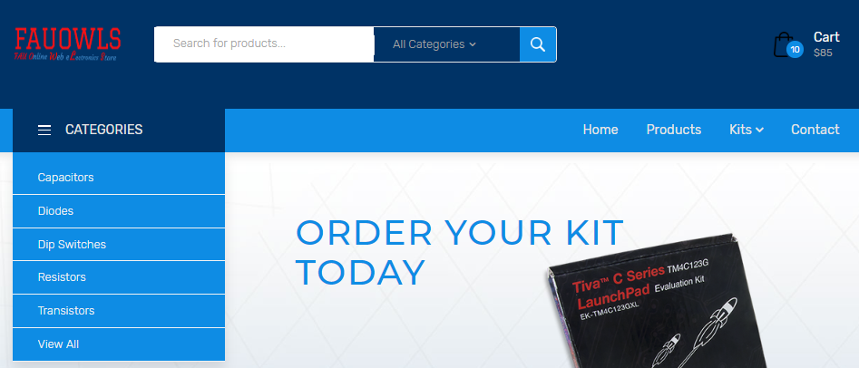

Homepage search results for “diode”:

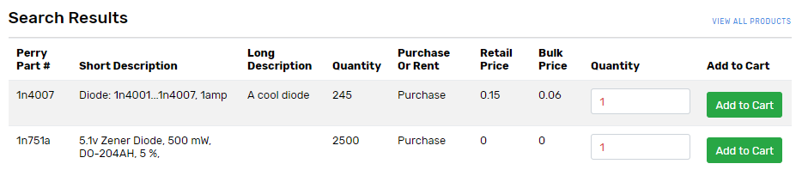

Homepage - view items in Category “Dip switches”:

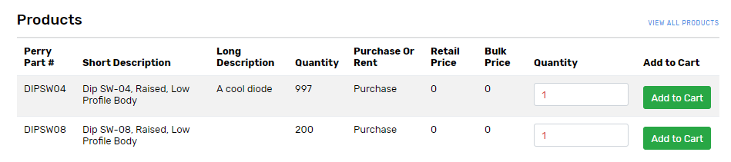

Homepage - full product listing, with “Add to Cart” buttons and adjustable Quantity fields:

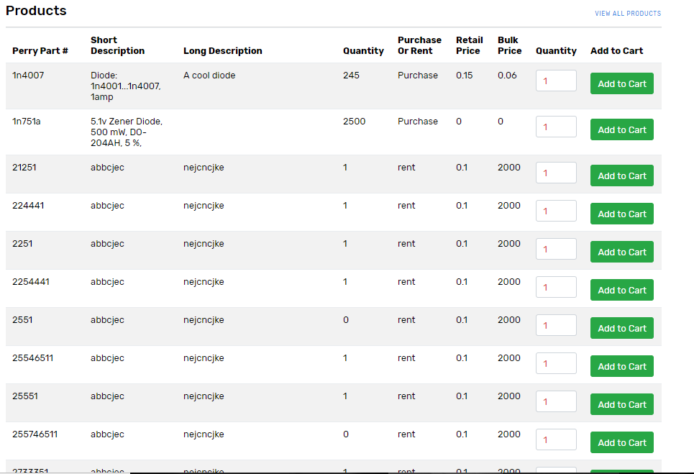

Order specific kit from homepage:

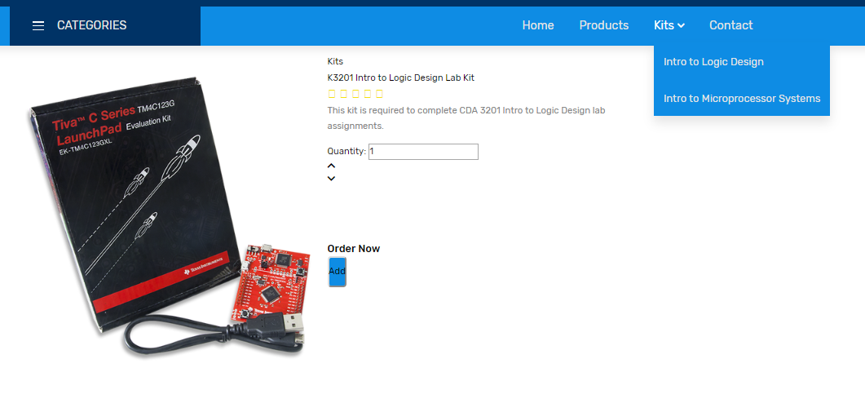

Viewing empty cart:



Log-in:

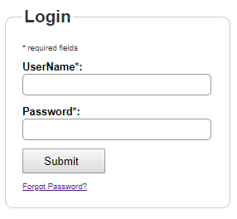

Main page after log-in, with options to go to main site, change password, view a sample only accessible once logged in, or log out:

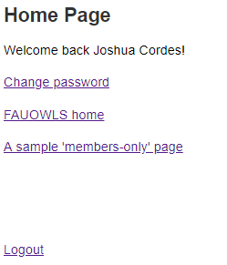

Change password when logged in:

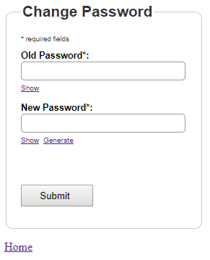

Main security page <http://lamp.cse.fau.edu/~CEN4010_S2018g03/FAUOWLS/security/> with links to register, confirm registration (not necessary when user clicks link in confirmation email), log in, or view a sample page only accessible to logged-in users:

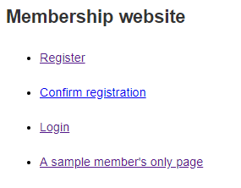

Register for an account:

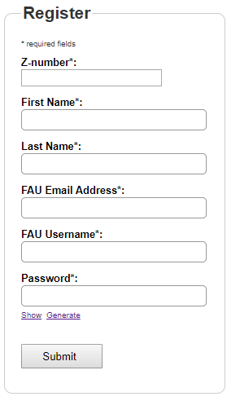

3.5 Google Analytics Plot (new account):

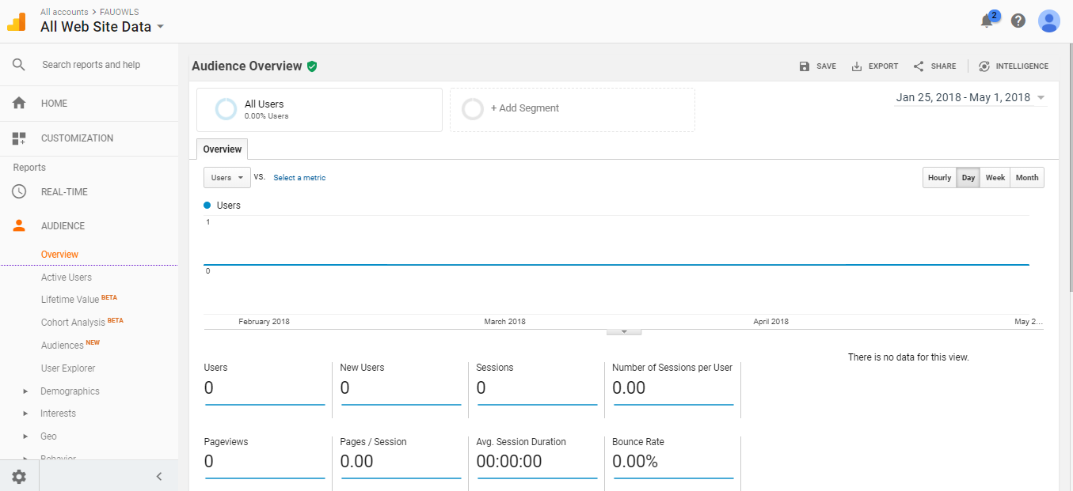

3.6 Team members’ contributions

1. Contributions:
   1. Martin Daniel Sanchez: 20 points
   2. Will Young: 20 points
   3. Alvaro Feola: 20 points
   4. Joshua Cordes: 20 points
   5. Brett Marks: 20 points
2. Specific contributions:
   1. Martin Daniel Sanchez: spreadsheet import and export, adding quantity to existing item; adding inventory to kit; viewing of pending, previous and cancelled orders with their details; functionality to mark orders as complete and cancel them; viewing of orders with rented items to be returned and their return selection; updating inventory and status of order; functionality to complete and validate order from cart; stored procedures to generate order and order detail updating inventory; stored procedures to create kits and to manage kits inventory; stored procedures to generate Inventory Transaction updating inventory; editing of database; recording and editing of milestone 4 and 5 videos; Scrum Master
   2. Alvaro Feola: adding products to cart, Github Master
   3. Joshua Cordes: Primary documentarian, adding single item, editing single item, log-in, registration, primary database manager, Product Owner (including all communication with Mr. Weinthal on team’s behalf after initial team discussion with him)
   4. Will Young: Adding new item, kit creation, Back-end Team Lead
   5. Brett Marks: Creation and management of homepage and other customer-side pages, image upload, product search, Front-end Team Lead
3. Number of commits to team github (many were of multiple files at a time):
   1. Will Young: 6
   2. Martin Daniel Sanchez: 19
   3. Joshua Cordes: 17
   4. Brett Marks: 10
   5. Alvaro Feola: 6

3.7 Post-project Analysis - by team lead Joshua Cordes in consultation with group members

Overall, as project team lead, I am extremely proud of the work we’ve accomplished as a group, on a project that at first may have seemed simple but would quickly turn dauntingly complex. Our main challenges related to scheduling and inexperience.

With scheduling, finding mutually agreed-upon times for full meetings or even Scrums; or time to sit down and design, engineer, and code our website; or time to complete the extensive documentation required was often exceedingly difficult. This was a strictly-online course, so there was never a time we would all be on campus as it was, and multiple group members work full time or otherwise have significant personal responsibilities that could make it tough at times to devote all their attention to this, on top of having other courses with their own academic obligations.

As to experience, only one or two of us five came in with even modest experience in programming outside our course work, with some lacking even academic experience with web programming, a key skill in this project. Having to study up quickly on languages we either may have never used, or had not used in some time, was a task in and of itself that could at time slow the development of our code.

In the future, to allay some of these challenges, we could more clearly delineate back end and front end teams. There being only five of us, it seemed at first that trying to box anyone in would be detrimental, but in retrospect, being able to schedule meetings between just back-end team members to discuss back-end issues, and meetings between just front-end team member to discuss front-end issues, then less frequent full group meetings to integrate discussions, could have been easier for scheduling. We’d frequently have trouble sticking to meeting times as one group member or another would have to back out to prioritize other obligations (academic, professional, or otherwise). Just two or three people needing to mutually agree on meeting times might have been easier than needing all five. In the future, we would also plan better to mutually collaborate instead of siloing ourselves off into presumably independent tasks, only to discover that what one person was working on might actually depend heavily on something that had been quickly assigned to someone else.

We finished kit creation, adding to inventory both new and existing, login, registration, and rental listings. We would have liked to have finished implementing exporting of current rental listings and a live and interactive feed of new orders for Admin and Engineering Lab Staff users; negotiating kinks in our code for deleting items from inventory or managing the cart; uploading files other than spreadsheets and images; and management of service request tickets, vendor information, Mr. Weinthal’s sales order history, displaying different prices on an item to users of different types, and more detailed student account information. For any one of these, the primary factor in our lack of completion was simply a lack of time, as the project was far too complex to get absolutely everything we needed in the time we had, and some of these (e.g., vendor info) being of low importance to the basic functionality of the site. Another factor was sometimes not knowing how to tackle a new task and placing greater priority on ones with which we simply had more experience.

From this project, we have learned the importance of communication, teamwork, time management, and patience, for reasons previously laid out in this essay. Additionally, we have learned the importance of taming expectations and being mindful of our own limitations. As the project continued over the first two months or so of the semester, we would think of novel new features to add, which I would bring up with Mr. Weinthal, who would be excited by the idea. When we would actually go into design and implementation, however, many of these tasks were simply too low in priority relative to other, more basic features, and we would occasionally all but abandon them, such as with user comments and product reviews that would be displayed on the page dedicated for the given item in inventory. On the brighter side, we learned that a project as vast as this one can be tackled when we are motivated enough, and we learned important techniques in various computer languages, such as HTML, JavaScript, and especially PHP.